Curriculum Vitae

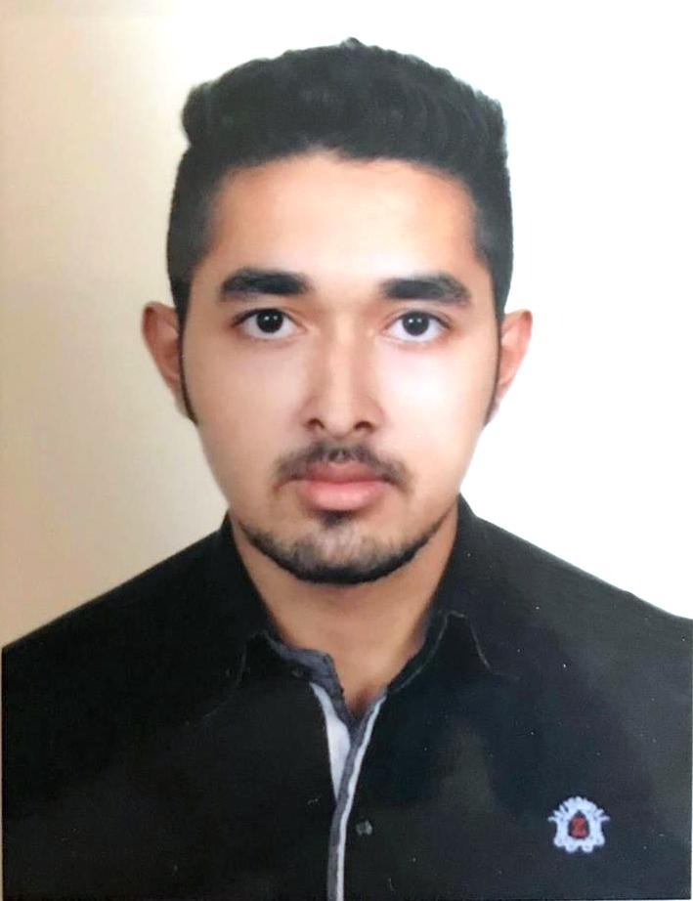

MD. NAZMUL ISLAM
Contact Address : 31/Ka Nadda ,Sarkar bari Masjid
Dhaka - 1200.
Cell Phone No. : 01724960086 , 01625255024
E-mail : polen5895@gmail.com

Career Objective

To excel as a professional in a well-established and reputed national or international organization where there is a scope to practice my experience and educational knowledge to reinforce my career as well as contribute to the people of Bangladesh to add value to first overall.

Educational Qualification

Bachelor of Science Study (B.sc)
University : Private University
Institute : Independent University ,Bangladesh
Subject : Major : Computer Science (CS)
Minor : Marketing
Result : CGPA -2.75
Year : 2018 (Last Semester)

Higher Secondary Certificate Examination (H.S.C)
Institute : Govt. Tolaram College
Result : GPA – 5.00
Year : 2013
Group : Science
Education Board : Dhaka

Secondary School Certificate Examination (S.S.C)
Institute : Adarsha School Narayanganj
Result : GPA – 5.00
Year : 2011
Group : Science
Education Board : Dhaka

Courses taken included

- Software Engineering
- Operating Systems Design
- Object-Oriented Development
- Java Development
- C/C++ Programming
- Network Programming
- Artificial Intelligence
- Customer Behaviour
- Distribution Management
- Advertising
- Web Development

Computer Proficiency

- Java
- C#
- C++/C
- HTML,JAVA Script,CSS
- Microsoft Office

Achievements

- The Best Student’s Performance Award -2011 for outstanding performance (GPA-5) in the SSC Examination 2011.
- Intra IUB Programming Contest 7th Place ,Summer -2015 from JUKTI Club of IUB
- Live in Field Experience certificate from FIVDB,Sylhet sponsored by IUB
- Center for Cognitive Skill Enhancement ,certificate of participation ,powered by HEQEP
- Best Batsman award organized by Banga sathi club of Narayanganj

Language Proficiency

- Bengali – Excellent in reading, writing & speaking.
- English – Good in reading, writing & speaking.

Professional Experience
.
Organization : Banglalink
Position : Contact Center Team Coordinator
Department : Customer Care.
Duration : From April, 2016 to October, 2016

Self - Assessment

- Well - groomed with good mannerism.
- Excellent interpersonal communication skill and pleasant personality.
- Able to work in a team.
- Energetic, honest, hard worker and fast learner.
- Good leadership and motivational capability.
- Maintain all types of account books, preparation of bills and registers with accuracy.

Interests

- Computer, Music, Traveling, Games & Sports etc.
- Participated in various social and cultural functions, Study tour etc.

Contact Address

Present Address : 31/Ka , Nadda Sarkar Bari Masjid
Dhaka :1200

Permanent Address : 356/3 ,Dewbog Narayanganj
Post: Narayanganj, Thana: Fatulla,
District: Narayanganj.

Personal Information

Name : Md. Nazmul Islam
Father’s Name : Md. Nazrul Islam
Mother’s Name : Naznin Islam
Date of Birth : 5th,August 1996
Place of Birth : Narayanganj, Bangladesh.
Religion : Islam
Blood Group : B+ (Positive)
Height : 5’ 8”
Marital Status : Single
Sex : Male
Nationality : Bangladeshi (by birth).

Declaration

I do hereby declare and certify that all the information stated above are true and complete to the best of my knowledge.

………………………..
MD. NAZMUL ISLAM
Date: 28-02-2018

